Steps for installing tensorflow for windows system

1. First install Anaconda
2. Create a [tensorflow](file:///C:\Users\91958\anaconda3\tensorflow.yml).yml file to install Tensorflow and dependencies
3. Launch Jupyter Notebook

Commands hierarchy:

1. First check the path of anaconda.exe file using (command C:\>where anaconda)
2. Set working directory (he working directory where you want to create the yml file.) in my case the path of working directory is (C:\Users\91958\anaconda3)
3. Create yml file or download it and save it at anaconda3 path (current working directory)
4. Create virtual environment for tensorflow.yml (conda env create -tensorflow.yml
5. pip install --upgrade tensorflow (This is optional)
6. Activate conda environment (conda env list /n >conda activate tensorflow
7. Type jupyter notebook
8. Now you have created the environment so you can work on tensorflow. Select python 3.7 (tensorflow environment)

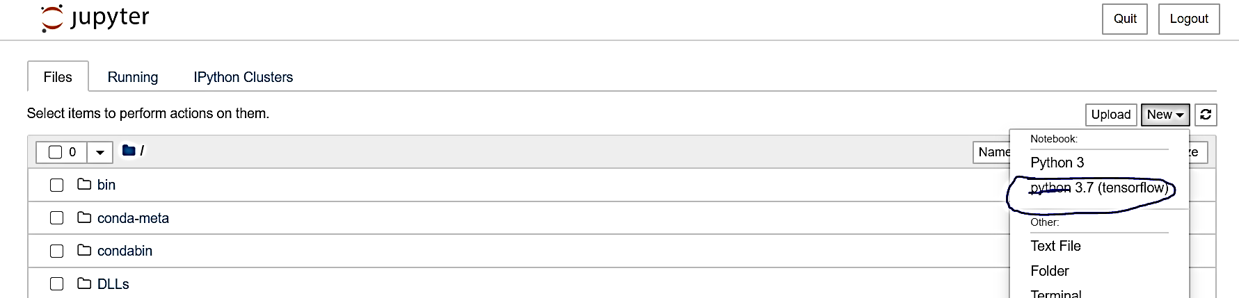

1. Reference:
2. For more information visit below web page
3. [How to Download and Install TensorFLow Windows and Mac.html](How%20to%20Download%20and%20Install%20TensorFLow%20Windows%20and%20Mac.html)